Health care advertisements from similar health care facilities.
Learner’s name
Institutional affiliation
Course title
Professor’s name
December 2019

Introduction
Different health care facilities adopt different modes of advertisements such as posters, videos etc. This paper will specifically deconstruct three advertisements employed by three cancer centers. It will analyze the marketing strategies employed on these advertisements and research on whether the advertisements are effective or not.

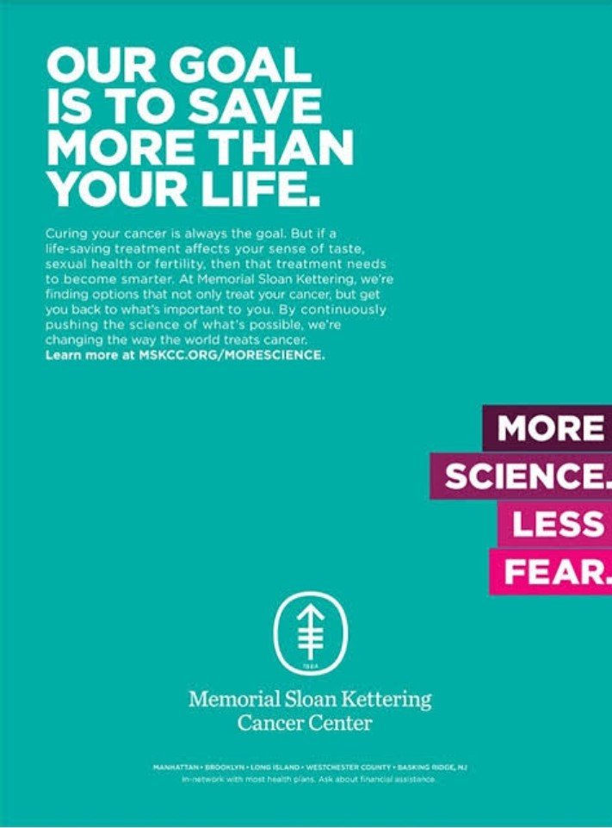
The first health care advertisement evaluated in this paper as shown above, is from the Memorial Sloan Kettering cancer center. The marketing strategy of the advertisement is on quality and convenience (Schwartz, et al, 2019). The advertisement emphasizes on both the quality of treatment offered to the cancer patients and its convenience. It explains that by saving one’s life through treatment their quality of life will not be compromised. The target demographic by the advertisement is generally cancer patients of all ages but more specifically cancer patients who are not only looking for a cure but also comfort while undergoing the treatment. It targets both cancer patients already undergoing treatment elsewhere by assuring them of more comfortable treatment and also those who have not yet started their treatment by assuring them both comfort and quality treatment.
The advertisement offers the incentive that the cancer patient will not lose their fertility, sense of taste or compromise their sexual health which is common in cancer patients undergoing treatment. The Advertisement shows that the treatment offered to the cancer patient is worth it in terms of the monetary value to be spent since the patient will not only receive up to date cancer treatment (modern science) but also continue doing what is important to them. The advertisement considers four of the five c’s of marketing. Considering Company and Competitors, it suggests that the memorial Sloan Kettering cancer center unlike other institutions saves not only the life of the cancer patient but also maintains the quality of the life saved. Considering Customers and Climate the advertisement assures patients of quality and comfortable treatment by exploring what modern science can offer.
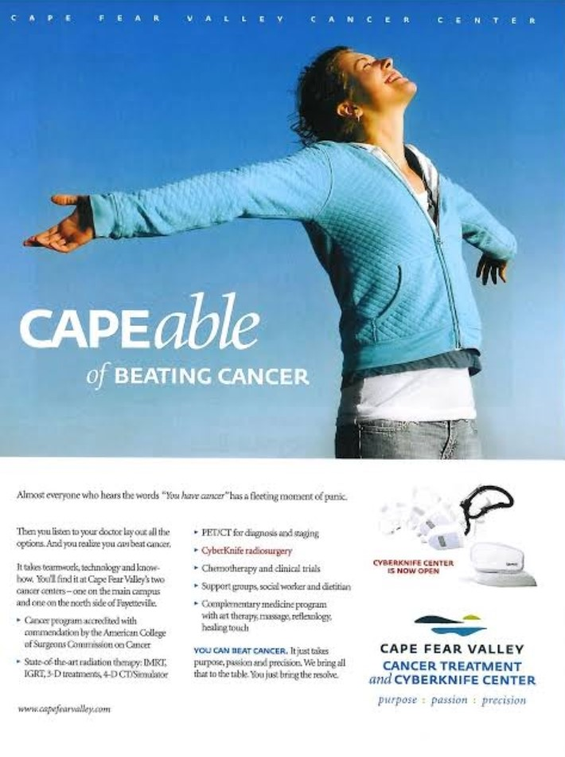
The second advertisement shown above is from the Cape Fear Valley Cancer Center. The marketing strategy of the advertisement is quality. It emphasizes on the quality of the treatment offered through exploring the precision of the modes of treatment by stating the state of the art equipment that the institution uses. The target demographic is generally all cancer patients but more specifically cancer patients with inoperable tumors due to the sensitivity of their location this is evidenced by the fact that Cyber Knife Radiosurgery is typed using a different color (red while the other words are in black) (Kadri, et al, 2018). The incentive the advertisement offers is hope and support through support groups, social workers and therapy.
The advertisement implies that the cost and effort required to acquire treatment at the Cape Fear Valley Cancer center is worth it since the equipment’s used are of the highest standard, the cancer program in the institution is recognized by the American College of Surgeons Commission on Cancer and the patient receives maximum support from both the staff and other patients. The advertisement takes into consideration the five c’s of marketing. Considering Climate and Competitors, the advertisement largely focuses on the level of technology employed by the institution i.e. Cyber knife radiosurgery. Considering Collaborators. It mentions the commendation of the cancer program by the American College of Surgeons Commission on Cancer. Considering Company and Customers, the advertisement shows that the institution offers the patients with both quality medical treatment and all the other support they require.

The third advertisement considered was from the Stanford Cancer center. The Market strategy is quality through emphases on the institution’s technology breakthrough, advanced clinical care, scientific research and recognition by the U.S news and world report. The target demographic is cancer patients. the only incentive the advertisement offers is quality health care. Considering tradeoffs and personal cost the advertisement offers a way to contact the hospital. Exploring the five c’s of marketing, the advertisement focuses on the quality of health care the Company offers to Customers and mentions that the Company is recognized by the U.S news and world report thus covering Collaborators and competitors.
Conclusion
From the study the advertisements from the three cancer care facilities are very different. The first one is very effective in targeting cancer patients concerned with both saving their lives and maintaining their quality of life but is ineffective in mentioning Collaborators to the center. The second one is effective in both the marketing strategy and in satisfying the five c’s of marketing and mainly focuses on the precision of technology advancements. The third one is not as comprehensive as the first two but is effective in targeting cancer patients in general.

References
Kadri, S., Ahmad, N., Mohammed, A. G., Arooj, S., & Mahmood, T. (2018, January). Cyber Knife Robotic Radiosurgery for challenging AVMS---A radiological review. European Congress of Radiology 2018.
Schwartz, L. M., & Woloshin, S. (2019). Medical Marketing in the United States, !997-2016. Jama, 321(1),80-96.
Studio, K.D. Studio 3-5 C’s of Marketing

